843-507-8373

Hilary L. Hunt’s new book “Wilderness Cry: A Scientific and Philosophical Approach to Understanding God and the Universe” is a shining beacon of wisdom.

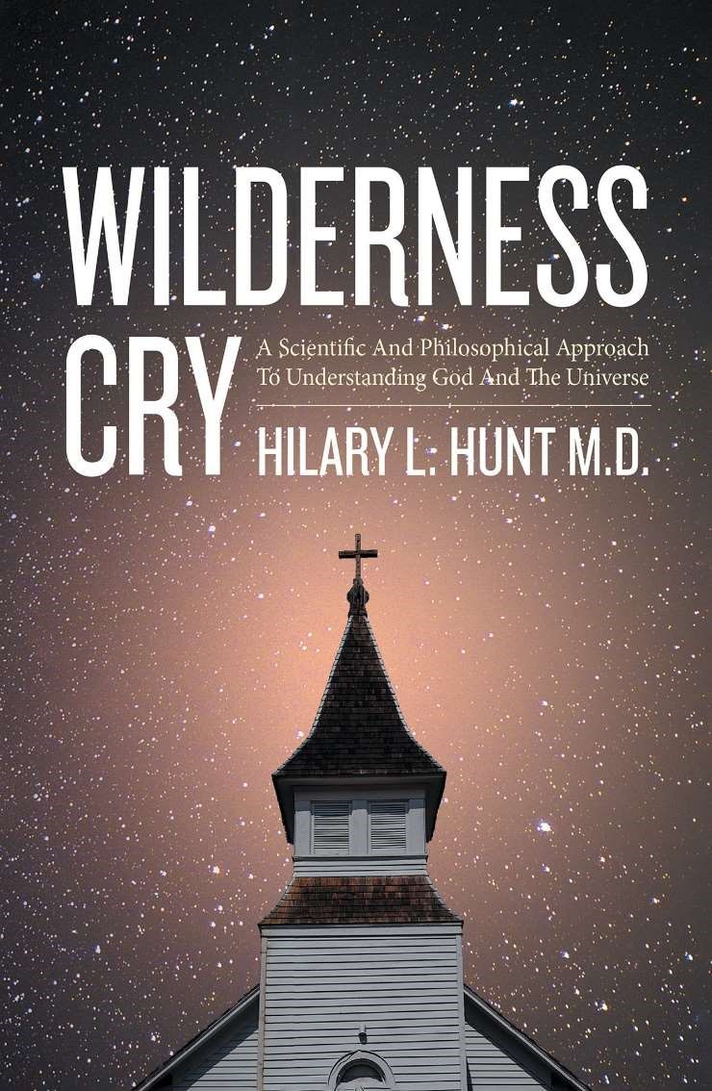
Hilary L. Hunt, M. D., a Vietnam War vet, Meritorious Service Medal awardee, and married father of five born in the Catholic community deep in the Bible Belt, has completed his new book, “Wilderness Cry: A Scientific and Philosophical Approach to Understanding God and the Universe”: a fascinating eye-opener.


From the absolute certainty of Christian dogma to the disillusionment generated by the vagaries of real life, the author was compelled to embark on ‘a journey of understanding.’ That endeavor would lead to a very different understanding of God and His universe based on science and philosophy. Readers are encouraged to be open minded when reading this material so as to grasp its full meaning.

11661
Hwy 707 Murrells Inlet, SC 29576

Published by Covenant Books of Murrells Inlet, South Carolina, Hilary L. Hunt’s new book is a thoughtful and deeply intelligent work that cuts through generations of ambiguous answers to arrive at a convincing, inspiring conclusion about God and the created world.

Readers can purchase “Wilderness Cry: A Scientific and Philosophical Approach to
Understanding God and the Universe” at bookstores everywhere, or online at the Apple iTunes store, Amazon, or Barnes and Noble.

Covenant Books is an international Christian owned and operated publishing house based in Murrells Inlet, South Carolina. Covenant Books specializes in all genres of work which appeal to the Christian market. For additional information or media inquiries, contact Covenant Books at 843-507-8373.

